- USER MANUAL

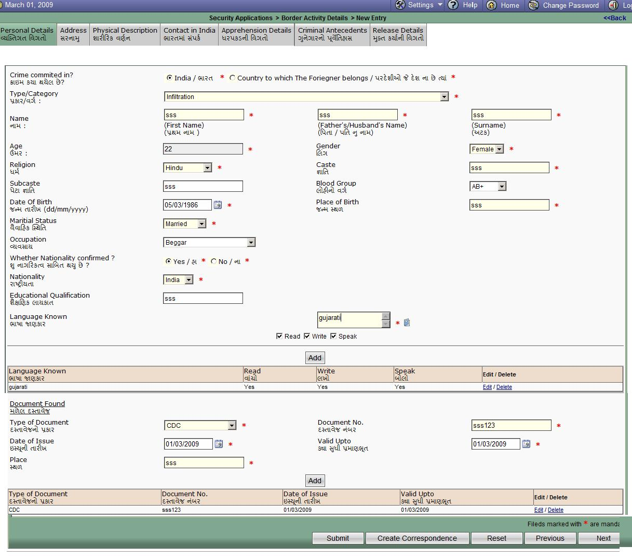

Fig 8.1 Personal Details Form

In this form all the Personal details of the accused and Documents Found from the accused is entered by the user. Both details have multiple add functionality.
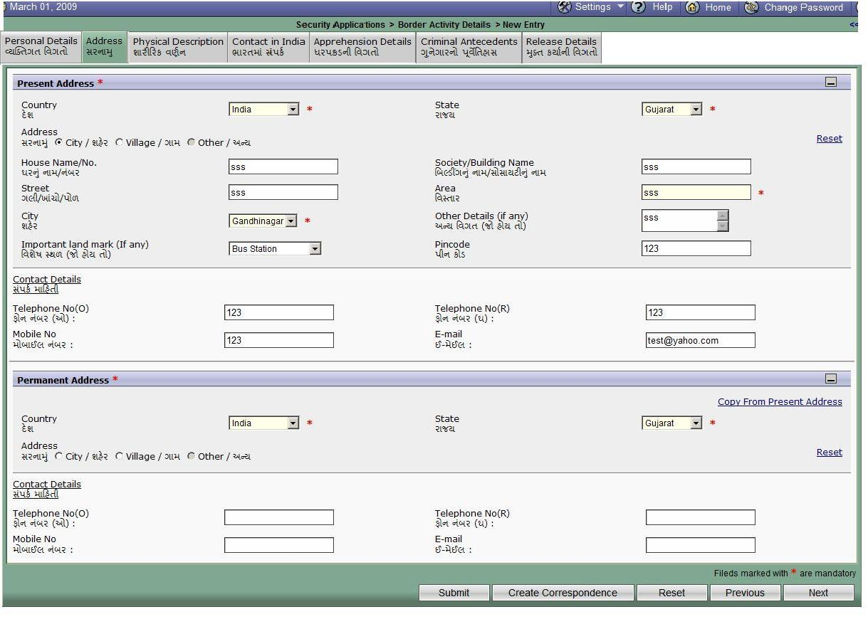
Fig 8.2 Address details form

In this form all the Contact Details of the accused entered by the user. Here two types of addresses are there. Present Address and permanent address of the accused.

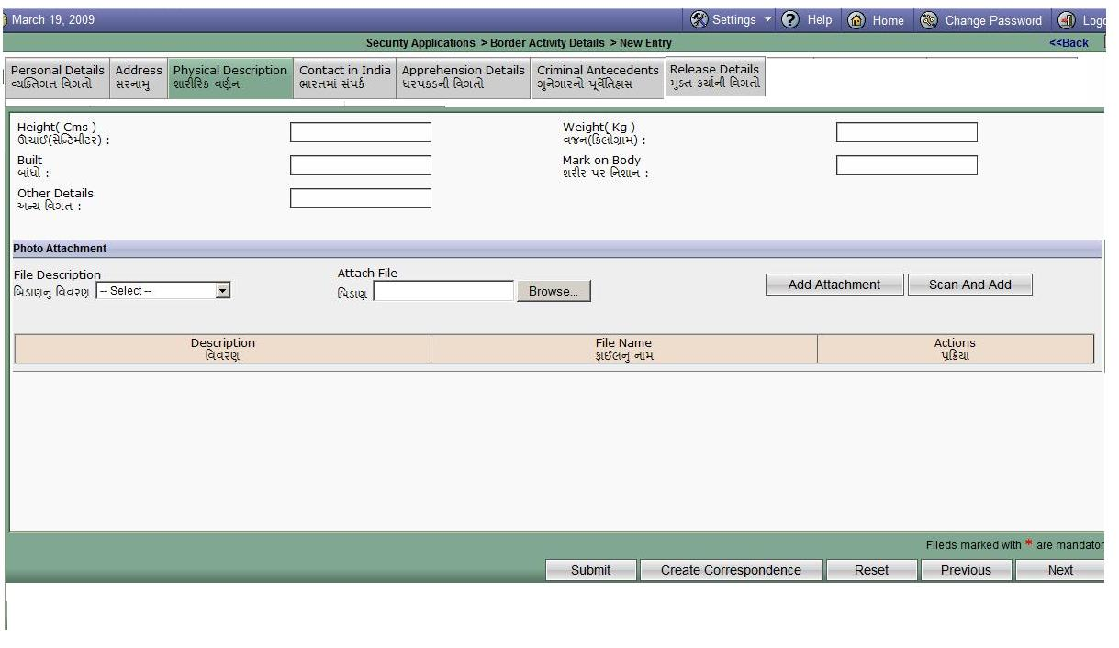
Fig 8.3 Physical Description form

In this form all the Physical Description of the accused entered by the user. Other then physical description photo attachment of the accused is there.
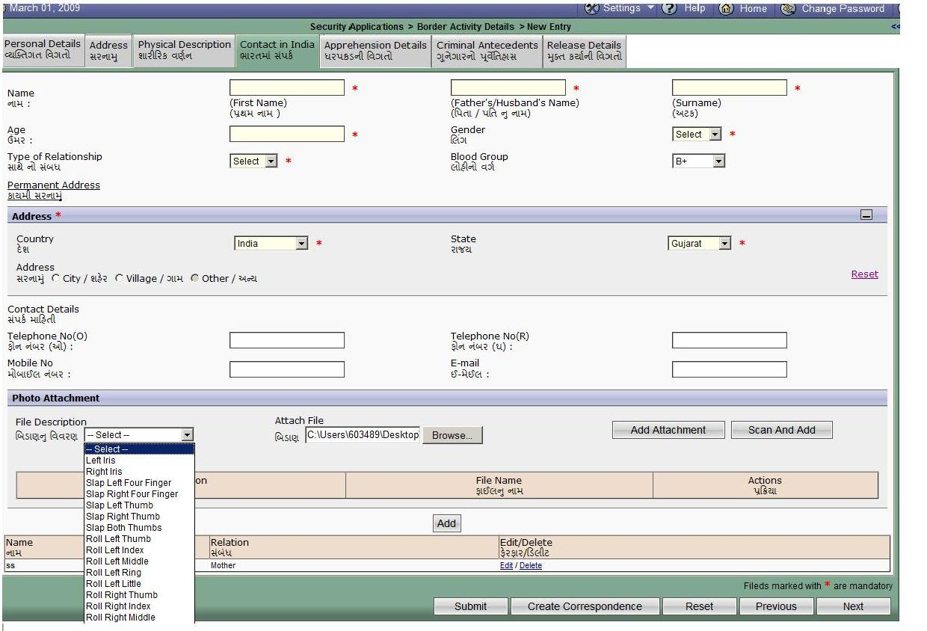

Fig 8.4 Contact in India details form

In this form Contact Details of relatives or friend of the accused in India entered by the user. Other then these details photo attachment is also there. More then one friend or relative’s entry can be done.

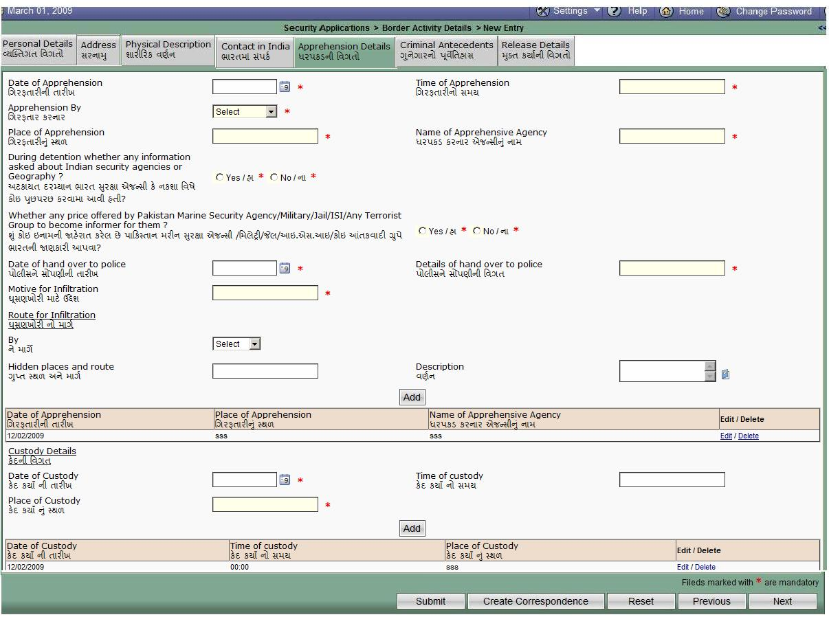

Fig 8.5 Apprehension details form

In this form Apprehension details of the accused entered by the user. Other then these details Custody details are also there. More then one Apprehension details and Custody details entry can be done.

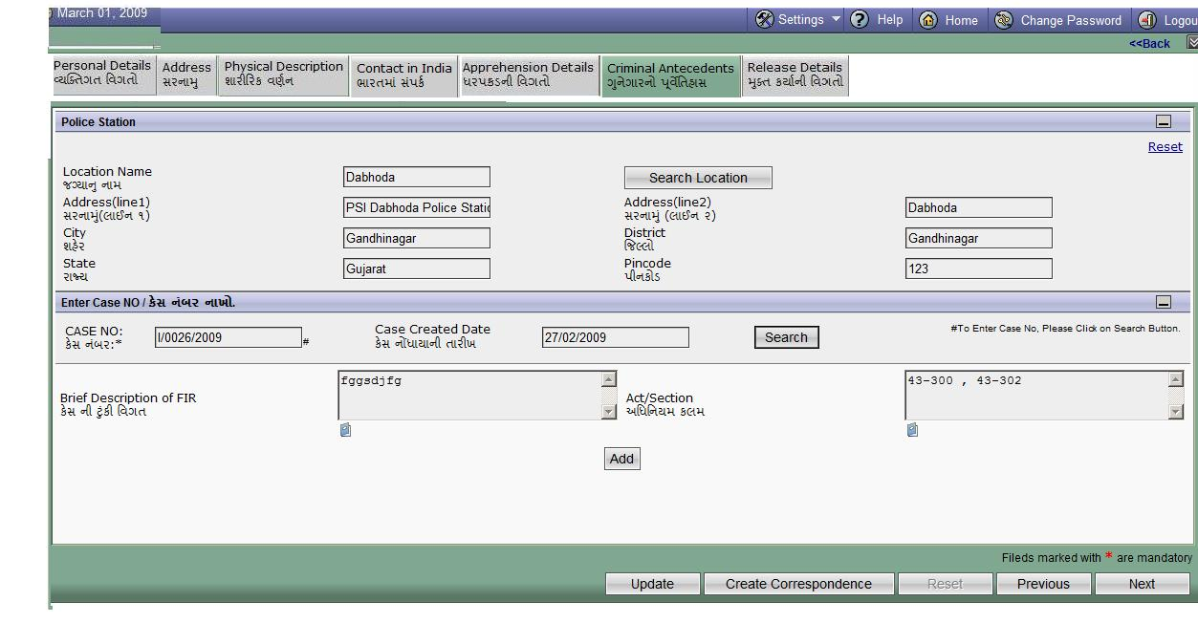

Fig 8.6 Criminal Antecedents details form

In this form Criminal Antecedents details of the accused entered by the user. Here two search components are there-Location search (To search location of the Police Station) and another is Case search(To search case details).

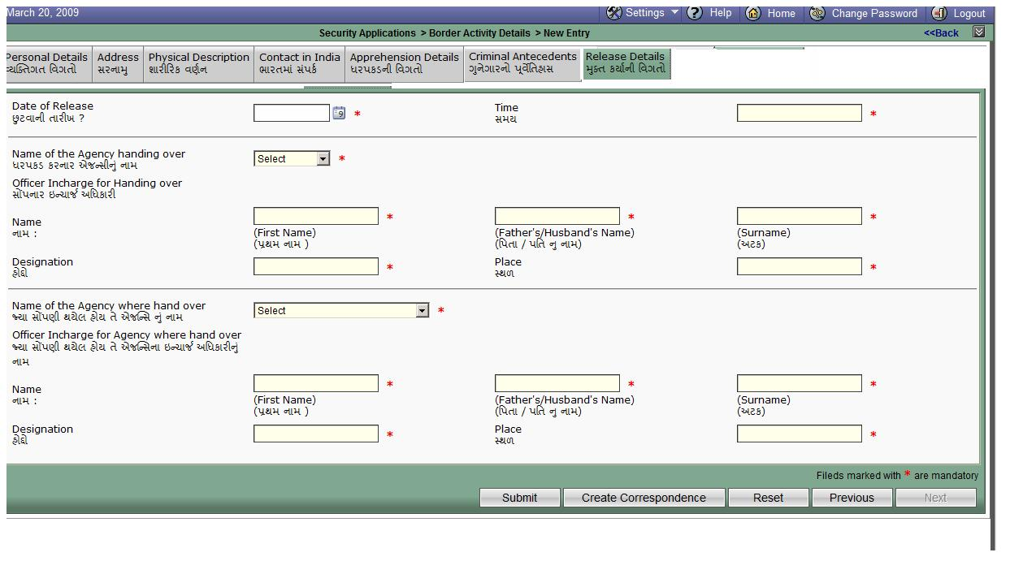Fig 8.7 Release details form

In this form Release details of the accused entered by the user. Release Date, time, Name and details of the agency handing over and Name and details of the agency hand over all these details are there in this form.

And after filling this(last form) ,submit the form. If submission is successful then Success message is displayed else Error massage will display.

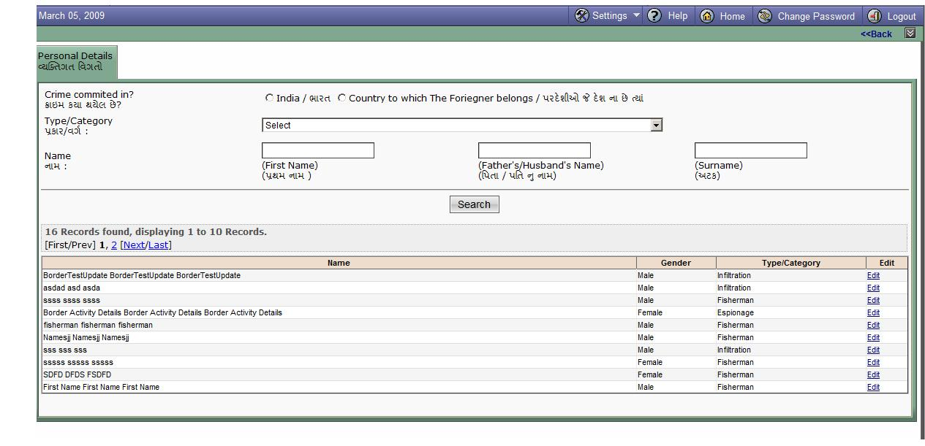

Fig 8.8 Edit/Update search details form

In this form just we have to entered particular details to search particular details. If no parameter is entered and if we press “Search” each and every data is displayed. By clicking on “edit” link all forms are populated for updation.

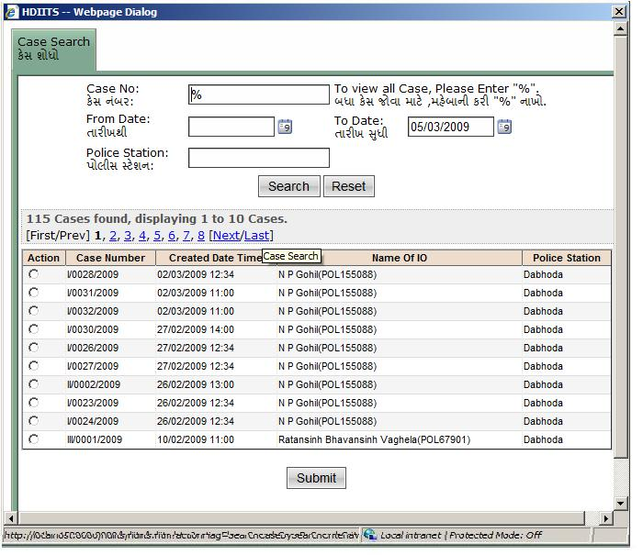

Fig 8.9 Case search form

Case search-To search case no and related details.

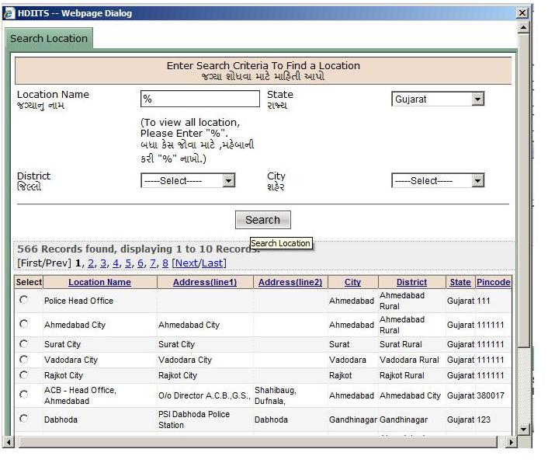

Fig 8.10 Location details form

Location search -To search location of the Police Station (complete address).

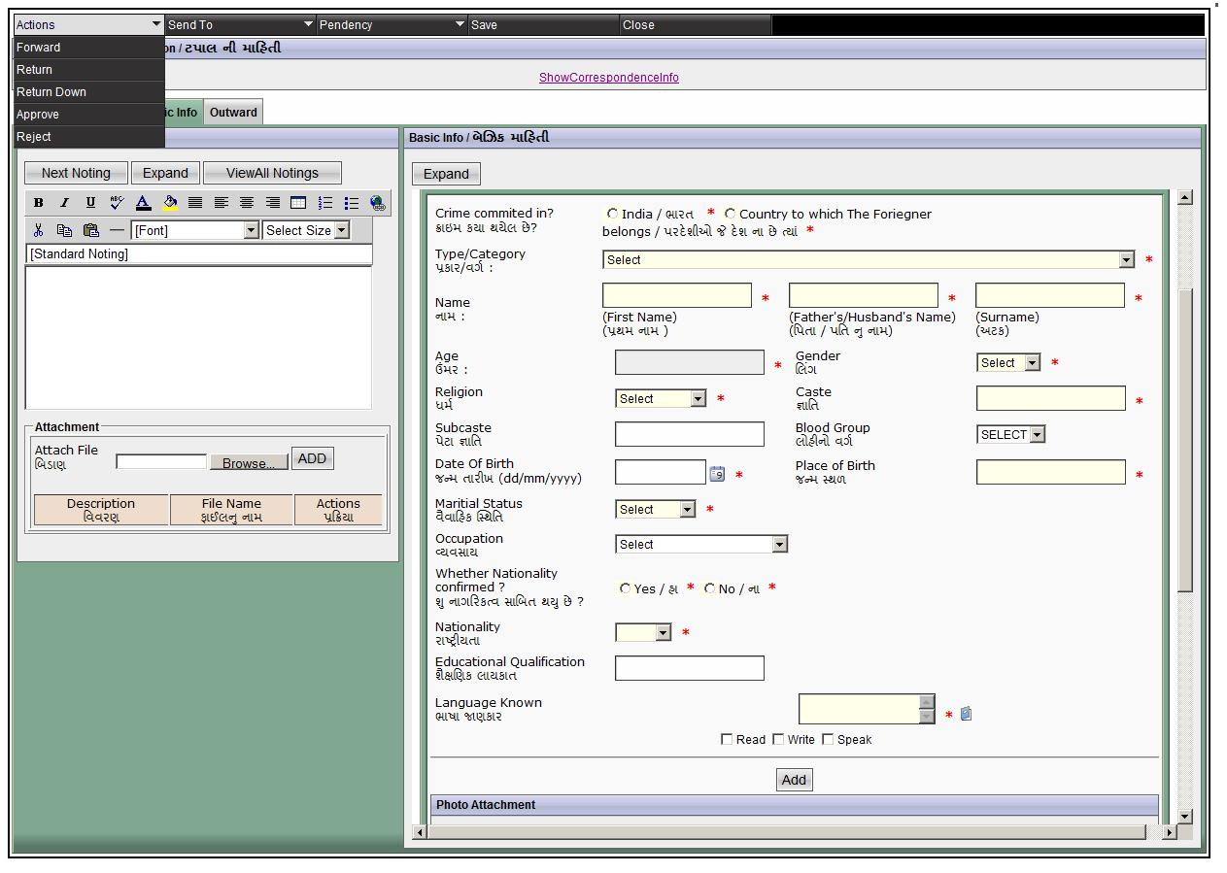

Fig 8.11 Correspondence

Here correspondence is created and lower level officer Forward these details to the higher level Officer. Higher level officer can approve or Reject this correspondence.
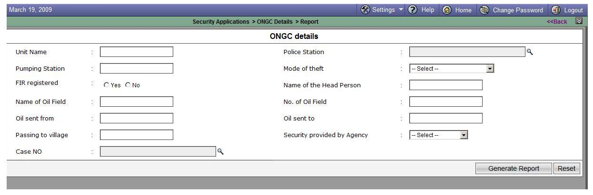

Fig 8.12 Ongc details – Report parameter page

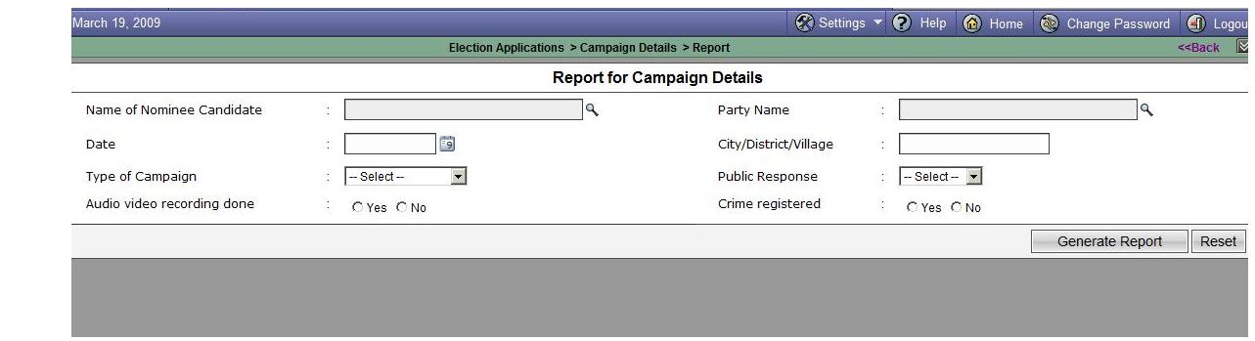

Fig 8.13 Campaign details – Report parameter page

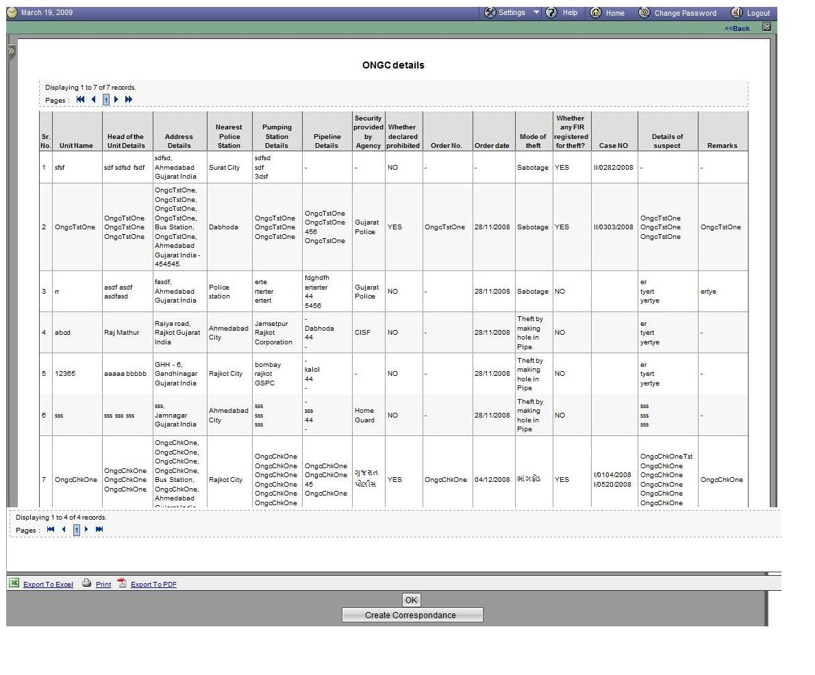
Fig 8.14 Ongc details – Report Generation page

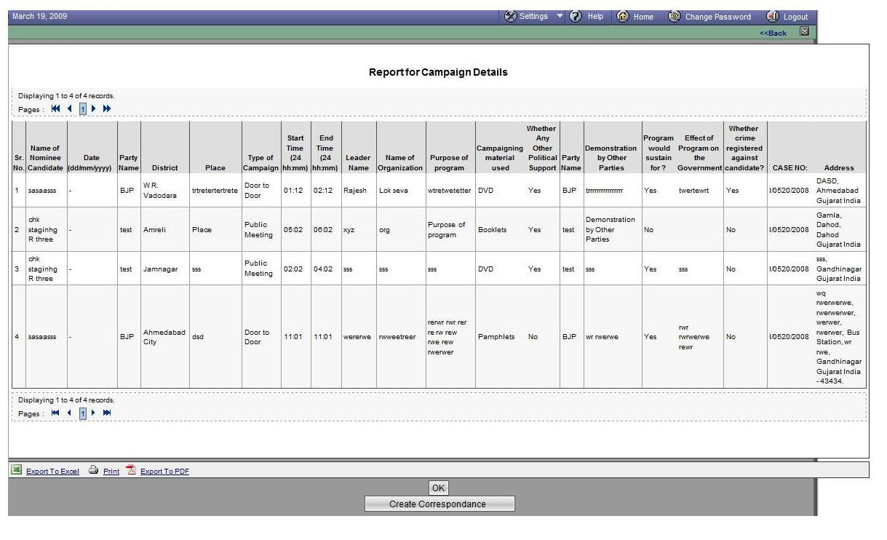
Fig 8.15 Campaign details – Report Generation page

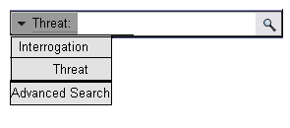

Fig 8.16 Search Parameter

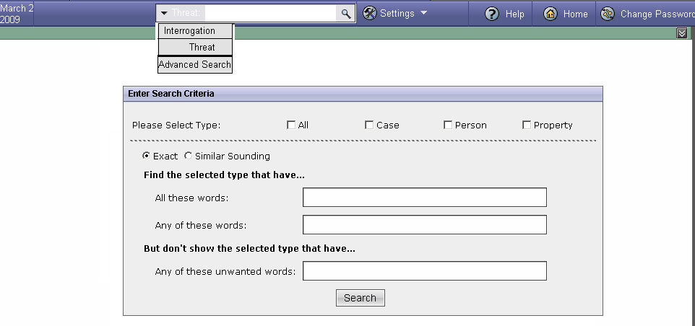

Fig 8.17 Advanced Search Page

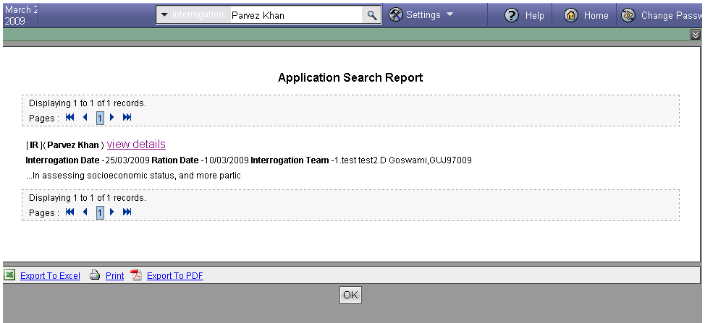

Fig 8.18 Advanced Search Page-Results

The User Manual Guide makes you facilitated to use the software in a very proper manner. For,
Further details use User Manual Guide as below.
 Help
This tool is provided with a concept of providing help to solve the queries related to the project.
 Home
This tool will divert the action to the home page
Password Change
This tool is provided to change the existing password.
 Logout
This tool is provided to exit from the current form and switch to the login page
 Attachment
This tool is used for attaching any file with application.
 Calendar
This tool provides a facility to select date.

